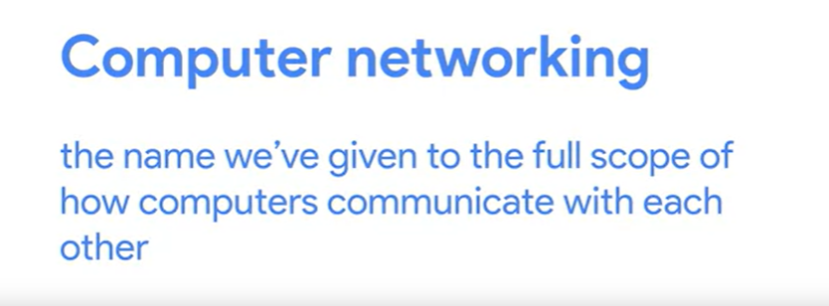

TCP/IP:

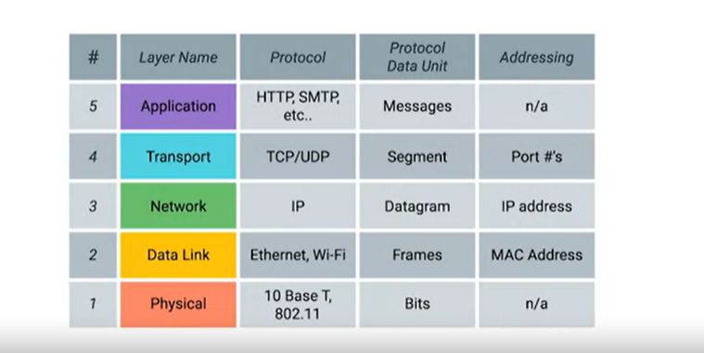

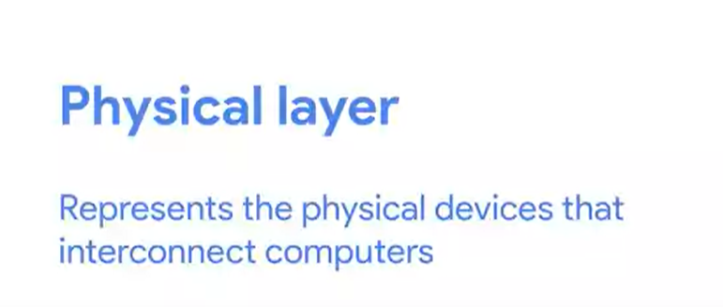

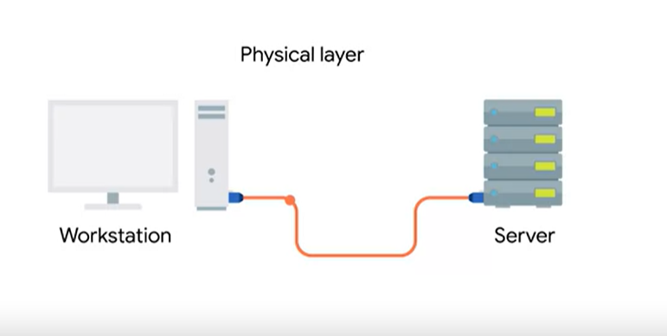

It represents the physical devices that interconnect computers.

This includes the specifications for

the networking cables and the connectors that join devices

together along with specifications

describing how signals are sent over these connections.

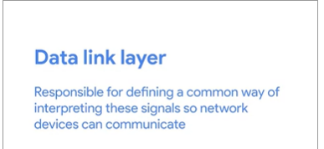

At this layer, we introduce our first protocols.

While the physical layer is all about cabling,

connectors and sending signals,

the data link layer is responsible for

defining a common way of interpreting these signals,

so network devices can communicate.

Lots of protocols exist at the data link layer,

but the most common is known as Ethernet,

although wireless technologies are becoming more and more popular.

Beyond specifying physical layer attributes,

the Ethernet standards also define a protocol responsible

for getting data to nodes on the same network or link.

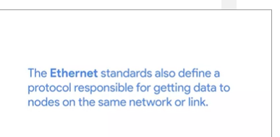

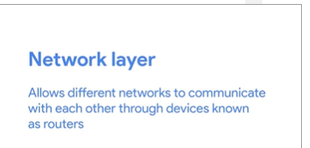



While the data link layer is responsible for getting data across a single link,

the network layer is responsible for getting data

delivered across a collection of networks.

Think of when a device on your home network connects with a server on the Internet.

It's the network layer that helps gets the data between these two locations.

The most common protocol used at this layer is known as IP or Internet Protocol.

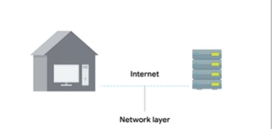



While the network layer delivers data between two individual nodes,

the transport layer sorts out

which client and server programs are supposed to get that data.



Cables:

* Copper cables
* Fiber Cables



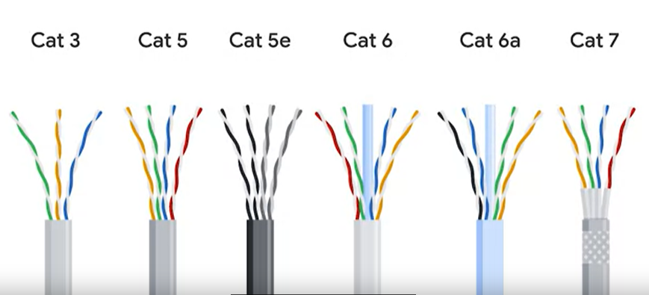

Cat 5e have replaced Cat5 cables because they reduce crosstalks.





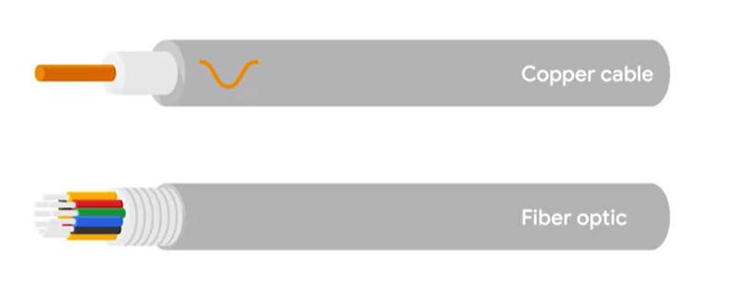



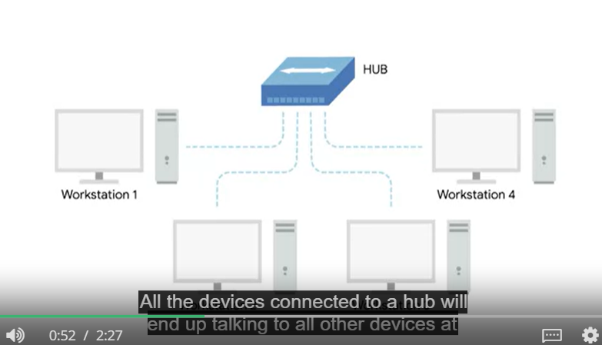



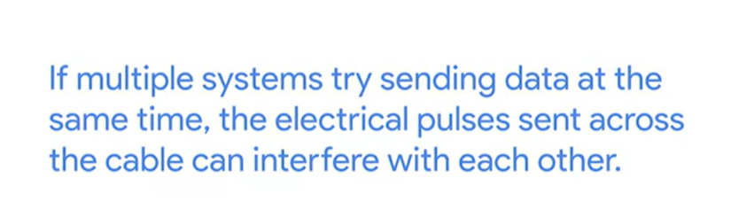

Instead of Hubs we use network switch now.

Switch is very similar to ahub

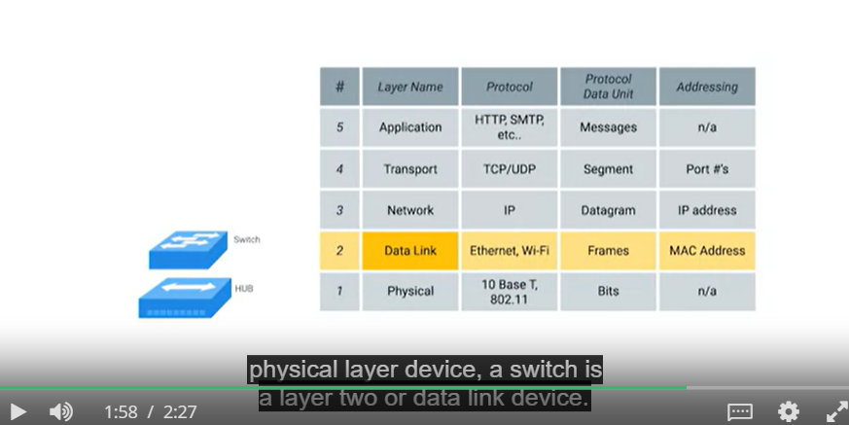

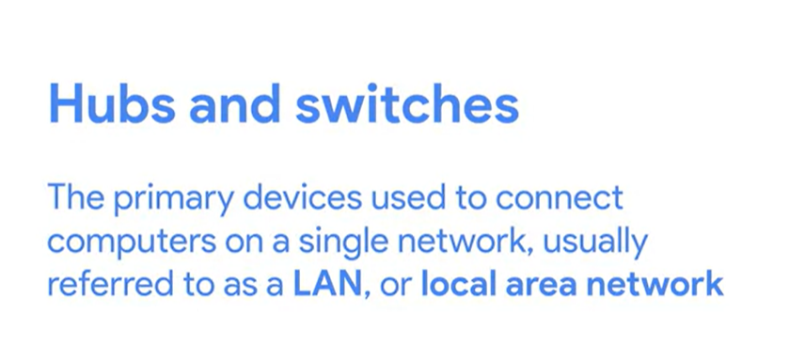

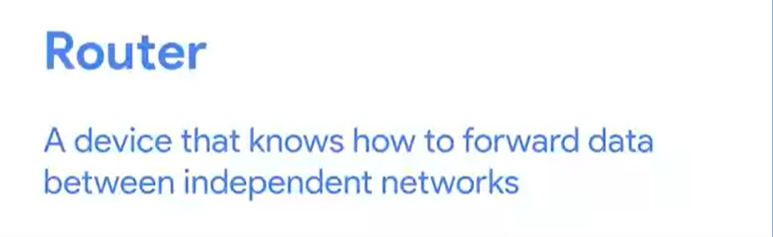

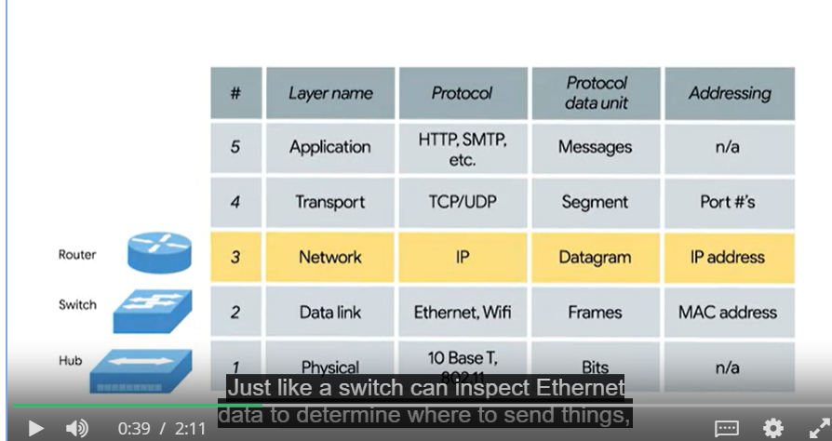

Router can see ip data

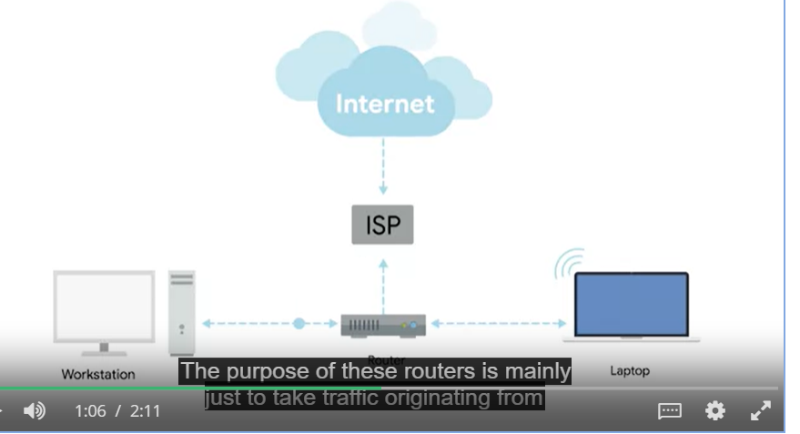



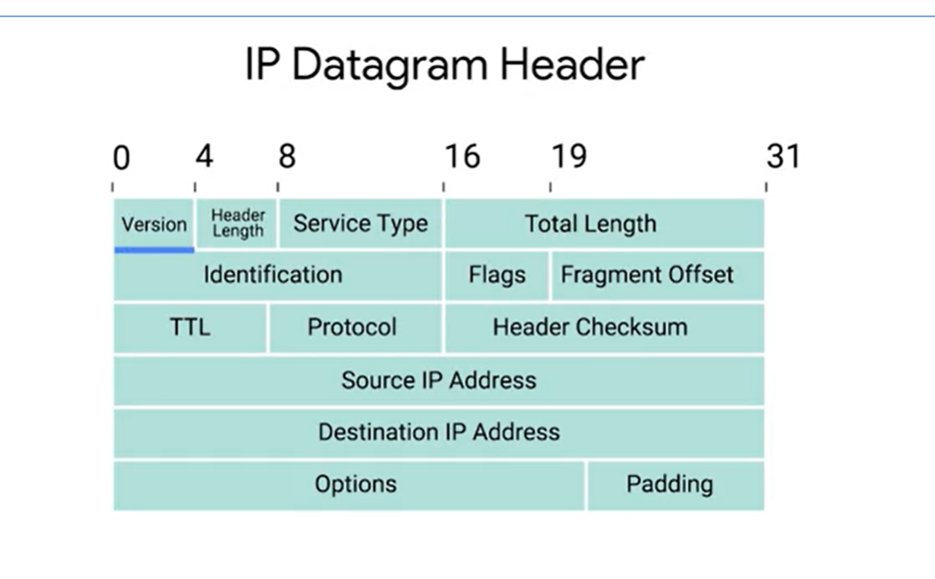

Class system is replaced by CIDR

